**OPTI 340 Spring 2013**

**Midterm Exam #1**

Feb. 19, 2013

Open book (Introduction to Lens Design, JMG, only)

Open notes, homework, design projects

Calculator allowed.

Individual work only

Arizona Code of Academic Integrity applies

8:00 AM till 9:15 AM (1hour 15 min.)

2 problems

Professor Yuzuru Takashima

Yuhao Wang

**Problem 1 [50pts]:**

Consider an optical system consisting of two positive thin lens elements having power of p1=0.01[1/mm] and p2=0.01[1/mm] (see Fig. 1). The index of refraction of the thin lens is n = 1.69. Object is located at –Infinity. For simplicity, we assume zero air spacing between the thin lens elements.

1. [10 pts] Calculate paraxial marginal ray angles, u1’, u2’. Assume the marginal ray height in the object space is 1 mm.
2. [10 pts] Calculate conjugate factor C1 and C2, for the lens element #1 and #2.
3. [10 pts] Calculate shape factor B1 and B2 of the lens element #1 and #2, for which the Seidel spherical aberration of each element is minimized.
4. [10 pts] Calculate radius of curvature R1 and R2 of the thin lens element #2.
5. [5 pts] Sketch the lens system. Cleary draw the shape of each lens element #1 and #2 based on the calculation. For purpose of drawing the lenses, add appropriate thickness.
6. [5 pts] Based on the drawing of the lens system, sketch trajectory of the marginal ray through the lens system. Indicate how the ray is deflected at each of the four lens surfaces. No calculation is needed.



**Fig.1**

**Problem 2: (50 pts, + Extra 5 pts)**

Figure 2 shows Y and X ray fan diagrams at a normalized field height H = 0 of an optical system having an F-number of 5.

1. (10 pts) Identify which aberrations are present.
2. (5 pts) Identify focusing position from the diagram (Paraxial focus?, Marginal focus?, Mid focus?, Minimum spot?, or something else?). State the reason.
3. (10 pts) Using the diagram, calculate wave aberration coefficients with units.
4. (10 pts) Based on the coefficients calculated in (c), draw the wave fan diagram. Clearly mark the peak-to-valley value of the wave aberration and its location on the yp-axis.
5. (5 pts) Calculate the extent of the spot at paraxial focus.
6. (10 pts) At paraxial focus, sketch longitudinal aberration as a function of normalized pupil coordinate yp. Clearly indicate the maximum amount of longitudinal aberration with units at yp=1.
7. (Extra 5 pts) Estimate the extent of the spot at marginal focus.

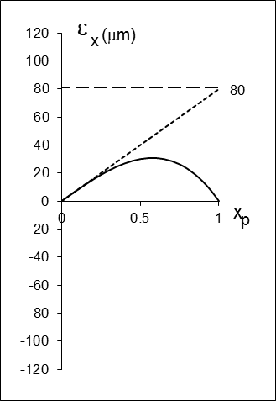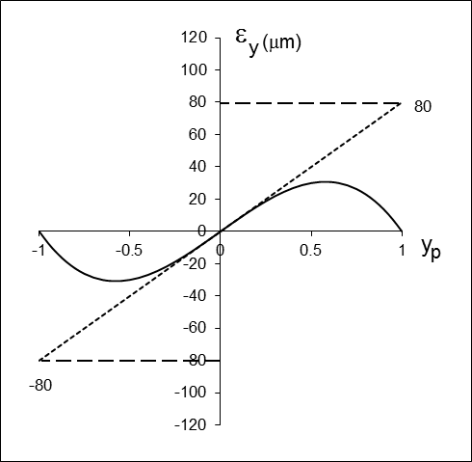

Fig. 2